ASSIGNMENT # 2-2 Due on 9/12/19 Student # …………… Name ………………………….

**STATICS** ***UDM ENGR 3120*** - ***BUCT MEC 1701-1703*** ***CHAPTER 3 – Rigid Bodies*** Student Name……………….........

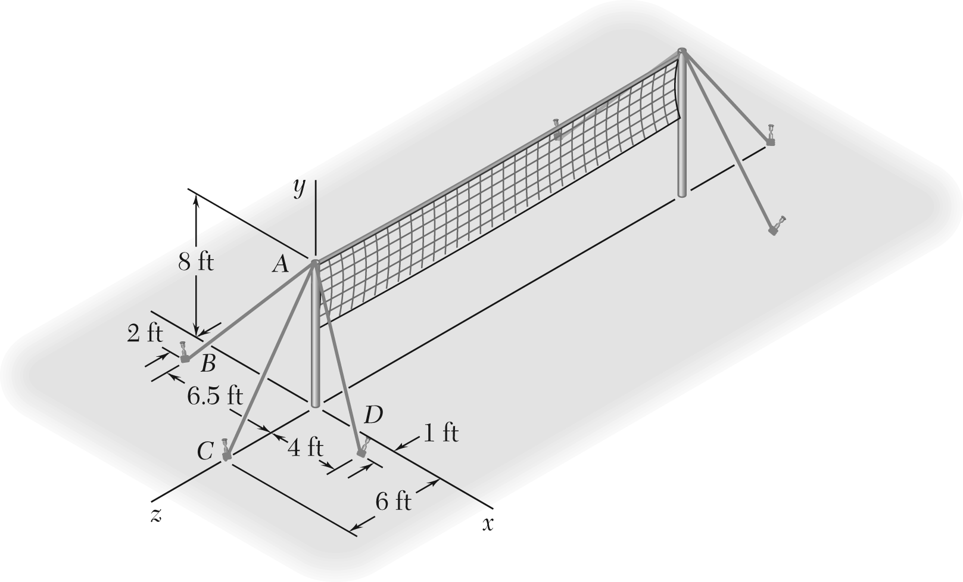

Consider the volleyball net shown.

Determine the angle formed by guy wires *AB* and *AC*.

Determine the angle formed by guy wires *AC* and *AD*.